USER STORIES

User Story 1 :

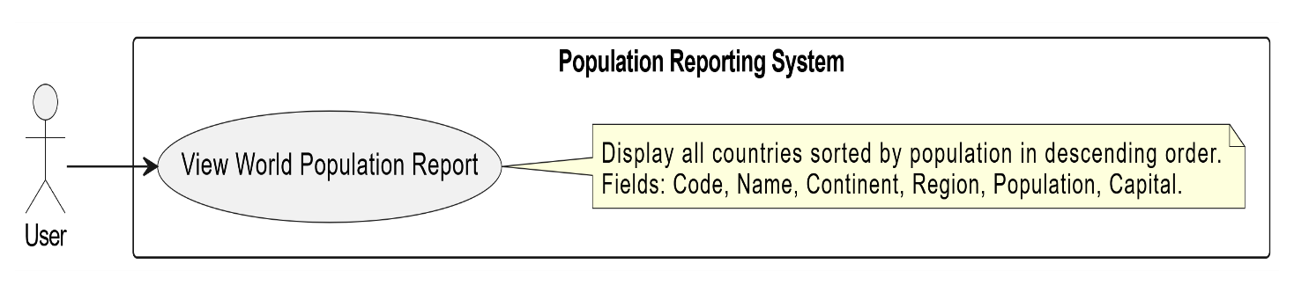

User Story 2 :

User Story 3 :

User Story 4 :

User Story 5 :

